Your Paper's Title Starts Here: Please Center
use Helvetica (Arial) 14
FULL First Author^{1, a}, FULL Second Author^{2,b} and Last Author^{3,c}
¹Full address of first author, including country
²Full address of second author, including country
³List all distinct addresses in the same way
ªE-mail, ^{b}E-mail, ^{c}E-mail
Keywords: List the keywords covered in your paper. These keywords will also be used by the publisher to produce a keyword index.
For the rest of the paper, please use Times Roman (Times New Roman) 12 with 1.25 line spacing.
Abstract (18 pounds before paragraph and 6 pounds after paragraph for the headings)
This template explains and demonstrates how to prepare your camera-ready paper. The best is to read these instructions and follow the outline of this text. Please make the page settings of your word processor to A4 format (21 x 29,7 cm or 8 x 11 inches); with the margins: bottom 1.5 cm (0.59 in) and top 2.5 cm (0.98 in), right/left margins must be 2 cm (0.78 in).
Introduction
All manuscripts must be in English, also the table and figure texts, otherwise we cannot publish your paper. Please keep a second copy of your manuscript in your office. When receiving the paper, we assume that the corresponding authors grant us the copyright to use the paper for the book or journal in question. Should authors use tables or figures from other Publications, they must ask the corresponding publishers to grant them the right to publish this material in their paper. Use italic for emphasizing a word or phrase. Do not use boldface typing or capital letters except for section headings (cf. remarks on section headings, below).
Organization of the Text
Section Headings. The section headings are in boldface capital and lowercase letters. Second level headings are typed as part of the succeeding paragraph (like the subsection heading of this paragraph).
Page Numbers. Do not number your paper:
Tables. Tables (refer with: Table 1, Table 2, ...) should be presented as part of the text, but in such a way as to avoid confusion with the text. A descriptive title should be placed above each table. Units in tables should be given in square brackets [meV]. If square brackets are not available, use curly {meV} or standard brackets (meV).
Special Signs. for example , α γ μ Ω () ≥ ± ●Γ {110} should always be written in with the fonts Times New Roman or Arial, especially also in the figures and tables.
Macros. Do not use any macros for the figures and tables. (We will not be able to convert such papers into our system)
Language. All text, figures and tables must be in English.
Figures. Figures (refer with: Fig. 1, Fig. 2, ...) also should be presented as part of the text, leaving enough space so that the caption will not be confused with the text. The caption should be self-contained and placed below or beside the figure. Generally, only original drawings or photographic reproductions are acceptable. Only very good photocopies are acceptable. Utmost care must be taken to insert the figures in correct alignment with the text. Half-tone pictures should be in the form of glossy prints. If possible, please include your figures as graphic images in the electronic version. For best quality the pictures should have a resolution of 300 dpi(dots per inch). Color figures are welcome for the online version of the journal. Generally, these figures will be reduced to black and white for the print version. The author should indicate on the checklist if he wishes to have them printed in full color and make the necessary payments in advance.
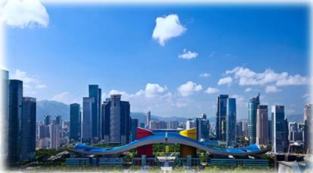 | 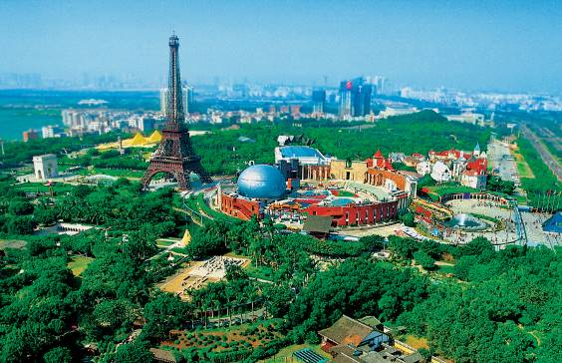
Fig.1 –Caption 1(Times New Roman 11) | Fig.2–Caption 2(Times New Roman 11)

Equations. Equations (refer with: Eq. 1, Eq. 2, ...) should be indented 5 mm (0.2"). There should be one line of space above the equation and one line of space below it before the text continues. The equations have to be numbered sequentially, and the number put in parentheses at the right-hand edge of the text. Equations should be punctuated as if they were an ordinary part of the text. Punctuation appears after the equation but before the equation number, e.g.

 | c² = a² + b². | (1)
Literature References
References are cited in the text just by square brackets [1]. (If square brackets are not available, slashes may be used instead, e.g. /2/.) Two or more references at a time may be put in one set of brackets [3,4]. The references are to be numbered in the order in which they are cited in the text and are to be listed at the end of the contribution under a heading References, see our example below.
Summary
If you follow the “checklist” your paper will conform to the requirements of the publisher and facilitate a problem-free publication process.
References
[1] J. van der Geer, J.A.J. Hanraads, R.A. Lupton, The art of writing a scientific article, J. Sci. Commun. 163 (2000) 51-59.
Reference to a book:
[2] W. Strunk Jr., E.B. White, The Elements of Style, third ed., Macmillan, New York, 1979.
Reference to a chapter in an edited book:
[3] G.R. Mettam, L.B. Adams, How to prepare an electronic version of your article, in: B.S. Jones, R.Z. Smith (Eds.), Introduction to the Electronic Age, E-Publishing Inc., New York, 1999, pp. 281-304.
[4] R.J. Ong, J.T. Dawley and P.G. Clem: submitted to Mechanical Engineering (2003)
[5] P.G. Clem, M. Rodriguez, J.A. Voigt and C.S. Ashley, U.S. Patent 6,231,666. (2001)
[6] Information on http://www.imcc1983.org/

